PROJECT DOCUMENTATION

AI FITTRACK

Technology Stack
Node.js • Express.js • MongoDB Atlas • Mongoose • JWT • bcrypt.js • Google Gemini AI • Postman
1.Introduction

Project Title:
AI FitTrack – Personalized Fitness Recommendations Powered by AI

Project Description :
AI FitTrack is a secure, scalable, AI-powered RESTful backend application developed to simplify workout tracking and provide intelligent fitness guidance. The backend is built using Node.js and Express.js, uses MongoDB with Mongoose for persistence, and integrates Google Gemini AI for personalized workout recommendations and fitness insights.
The application follows the Model–View–Controller (MVC) architecture. JWT-based authentication protects private resources, while bcrypt.js is used to securely hash passwords before storage. The API returns structured JSON responses so it can be consumed by a React application, mobile application, or API testing tool such as Postman.
Team information:

Team ID: SWTID-2026-4374

Team size: 4

Team leader:
GOKULNATH S ( gokulnaths.831@gmail.com )

Team members:
1.GOBINATH V ( velusamygobinath2007@gmail.com )
2.HARI M ( h898745@gmail.com )
3.HARISHANKAR S ( harishankarsengodan@gmail.com )

2. Project Overview
AI FitTrack is an AI-powered fitness tracking and recommendation system designed to help users manage their workout activities and receive personalized fitness guidance.
The application provides a RESTful backend using Node.js, Express.js, MongoDB, and Mongoose. It uses JWT authentication for secure access and bcrypt.js for password protection. Google Gemini is integrated to generate personalized workout recommendations and fitness insights.
Main Features
- User registration and login
- JWT-based authentication
- User profile management
- Workout creation, viewing, updating, and deletion
- Workout search
- AI-powered workout recommendations
- AI-powered fitness insights
- Centralized error handling
- REST API architecture

3. Architecture
AI FitTrack follows a layered architecture based on the MVC design pattern. The system separates routing, business logic, authentication, database operations, and AI services into independent modules.
When a client sends an HTTP request, Express receives it and forwards it to the appropriate route. Protected routes pass through authentication middleware, which validates the JWT. Controllers process validated requests and invoke database models or AI services. Mongoose handles MongoDB operations, while a dedicated service layer communicates with Google Gemini. The controller finally returns a structured JSON response.

Architecture Components
1.Client Layer
The client layer is the entry point. It can be a React application, mobile application, or Postman. It sends API requests, stores the JWT token after login, invokes workout and AI APIs, and displays JSON responses.
2. Express Server Gateway
The Express server starts the HTTP server, parses JSON requests, enables CORS, registers routes, connects middleware, and participates in centralized error handling.
3.Authentication Middleware
The middleware reads the Authorization header, extracts the JWT, verifies its signature, decodes user information, attaches it to the request, and rejects invalid or missing tokens.
4. Route Layer
Routes define endpoints for authentication, workouts, and AI features. They connect incoming HTTP requests to controller methods.
5.Controller Layer
Controllers validate input, execute application logic, invoke models or services, and generate standardized JSON responses.
6. Service Layer
The service layer contains reusable logic. The Gemini service prepares prompts and receives AI responses; the JWT service creates and verifies tokens; the password service hashes and compares passwords.
7. Database Layer
MongoDB stores persistent application data and Mongoose provides schema definitions, validation, and database operations.

4. Setup Instructions
Prerequisites
Install the following software:
- Node.js
- MongoDB
- npm
- Postman or Thunder Client
- Google Gemini API key
Installation
Clone or download the project and open the project folder in a terminal.
Install the required dependencies:
npm install

Environment Configuration
Create a .env file and configure the following variables:
PORT=5000
MONGO_URI=mongodb://localhost:27017/aifittrack
JWT_SECRET=your_secret_key
GEMINI_API_KEY=your_google_gemini_api_key
Replace the placeholder values with the appropriate configuration for your environment.

5. Folder Structure
The project follows a modular backend structure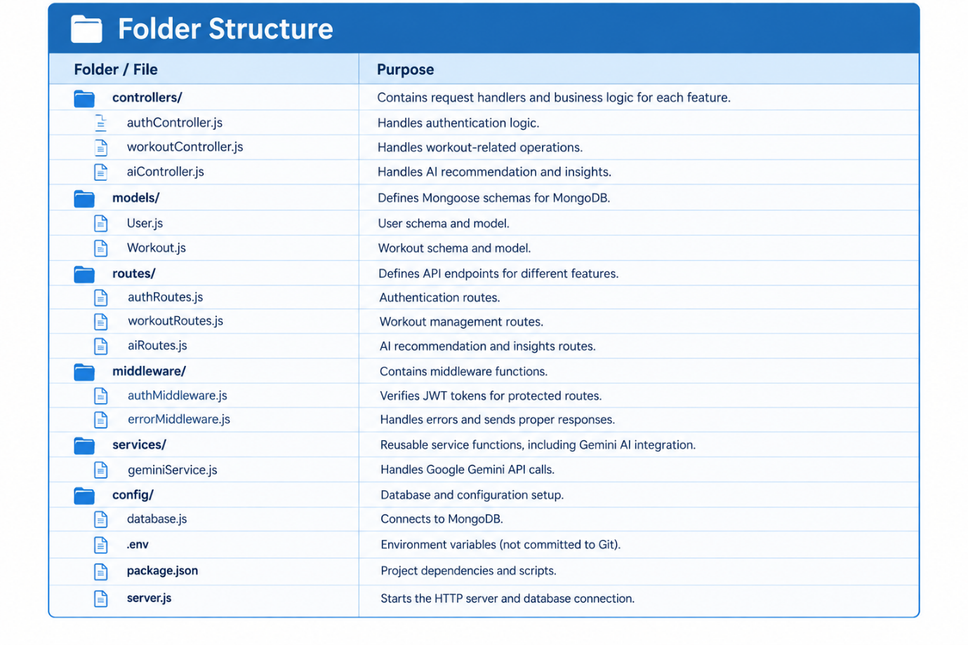

6. Running the Application
Step 1: Start MongoDB
Make sure MongoDB is running on the system.
Step 2: Install Dependencies
npm install
Step 3: Configure Environment Variables
Ensure that the .env file contains the required MongoDB, JWT, and Gemini API configuration.
Step 4: Start the Server
npm start
The server runs on the configured port, for example:
http://localhost:5000
The API can then be tested using Postman or Thunder Client.

7. API Documentation
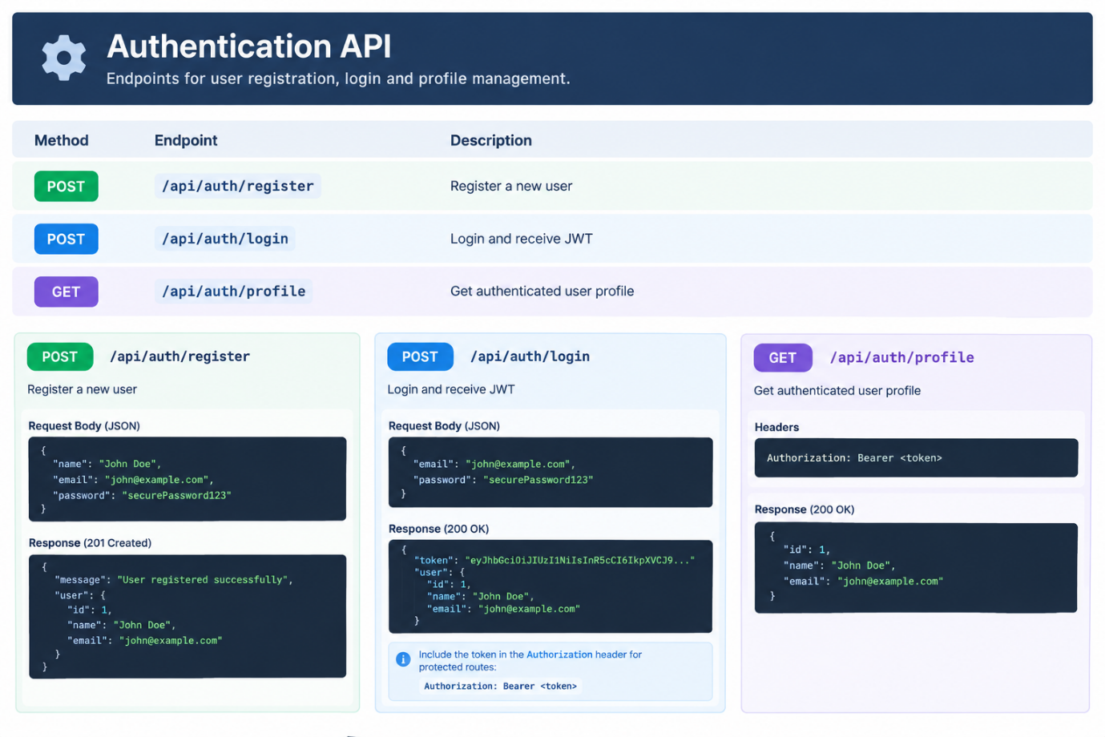

8. Authentication
AI FitTrack uses JWT (JSON Web Token) for authentication.
Registration
The user provides:
- Name
- Email
- Password
The password is securely hashed using bcrypt.js before being stored.
Login
The user provides their email and password. After successful authentication, the server generates a JWT token.
The token is then sent with protected API requests.
Example:
Authorization: Bearer <JWT_TOKEN>
Protected Resources
Authenticated users can access protected resources such as:
- User profile
- Workout records
- AI recommendations
- AI fitness insights

9. User Interface
The AI FitTrack system is designed to provide a simple interface for fitness management.
The user interface can provide the following sections:
Login / Registration
Users can create an account and securely log in.
Dashboard
The dashboard can display:
- Total workouts
- Workout duration
- Calories burned
- Recent workout activity
- AI-generated insights
Workout Management
Users can:
- Add workouts
- View workouts
- Edit workouts
- Delete workouts
- Search workout records
AI Recommendation
Users provide information such as:
- Age
- Fitness goal
- Experience level
The AI generates a personalized weekly workout plan.
Fitness Insights
The system can analyze:
- Total workouts
- Average workout duration
- Total calories burned
and generate fitness progress information and suggestions.

10. Testing
The APIs can be tested using Postman or Thunder Client.
Authentication Testing
Test:
- Successful registration
- Duplicate email registration
- Successful login
- Invalid login credentials
- Access with valid JWT
- Access without JWT
Workout Testing
Test:
- Create workout
- Retrieve workouts
- Retrieve workout by ID
- Update workout
- Delete workout
- Invalid workout ID
- Unauthorized access
AI Testing
Test:
- AI workout recommendation
- AI fitness insights
- Valid input
- Missing input
- Invalid input
- Gemini API response handling
Error Testing
Test:
- Invalid routes
- Invalid request data
- Database errors
- Authentication errors
- Server errors

11. Screenshots
The documentation can include screenshots of the following application modules:

Register User
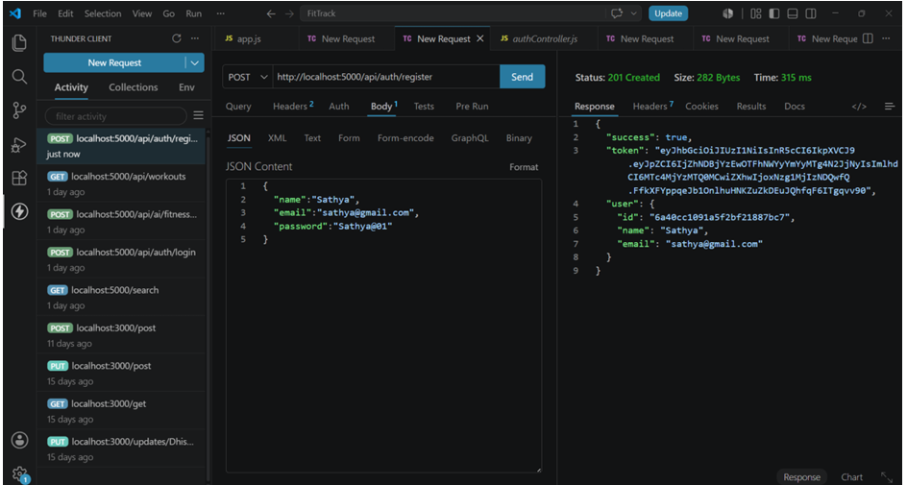

Login User
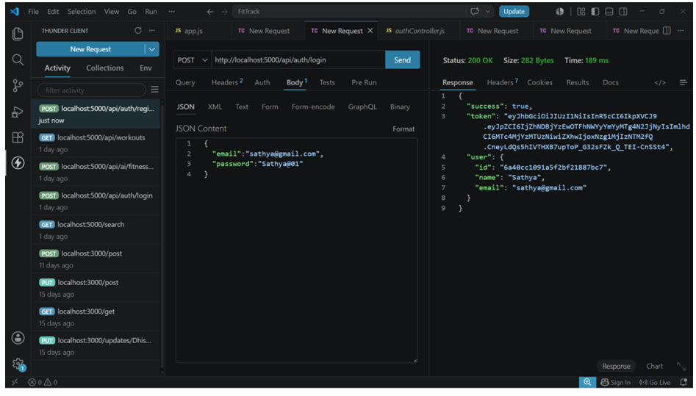

Get Profile
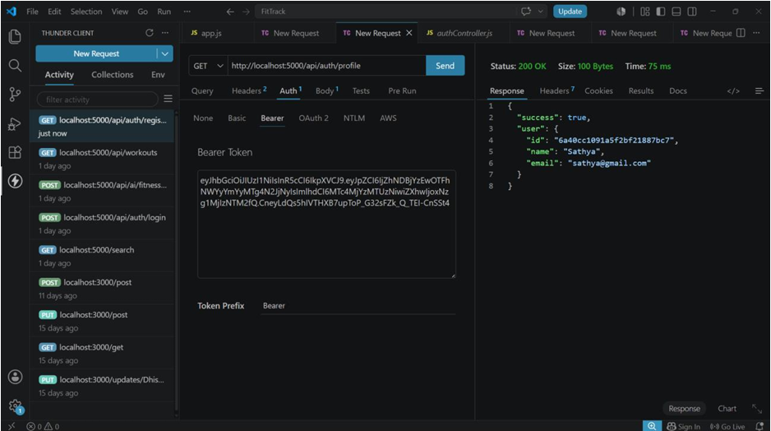

Workout API Testing

Add Workout
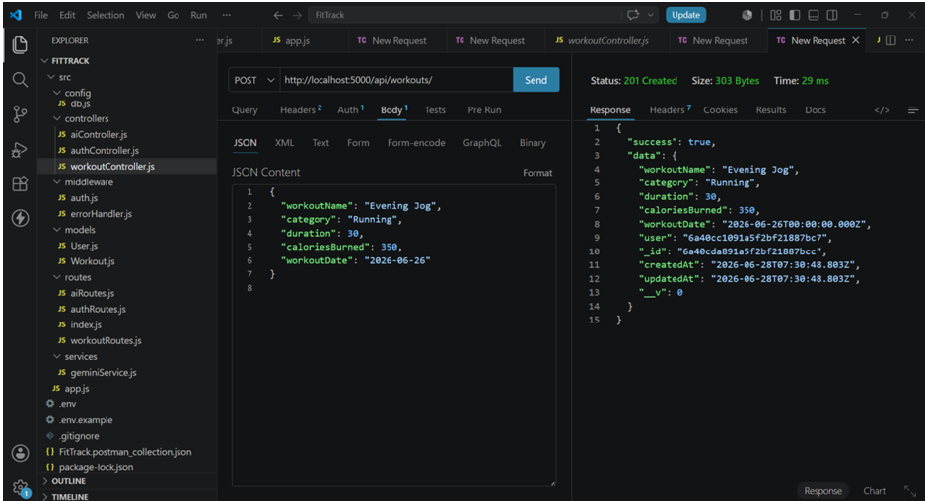

Get All Workouts
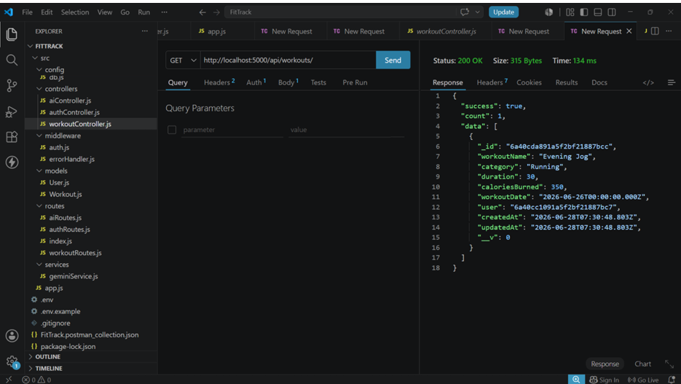

Get Workout By ID
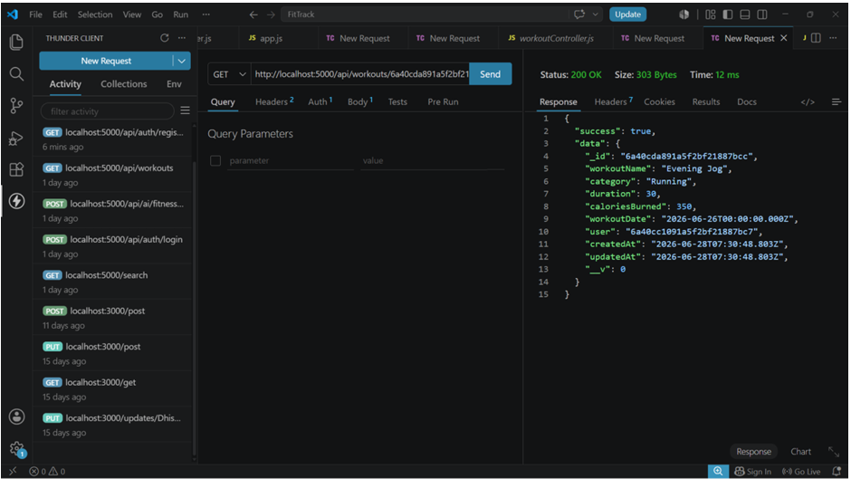

Update Workout
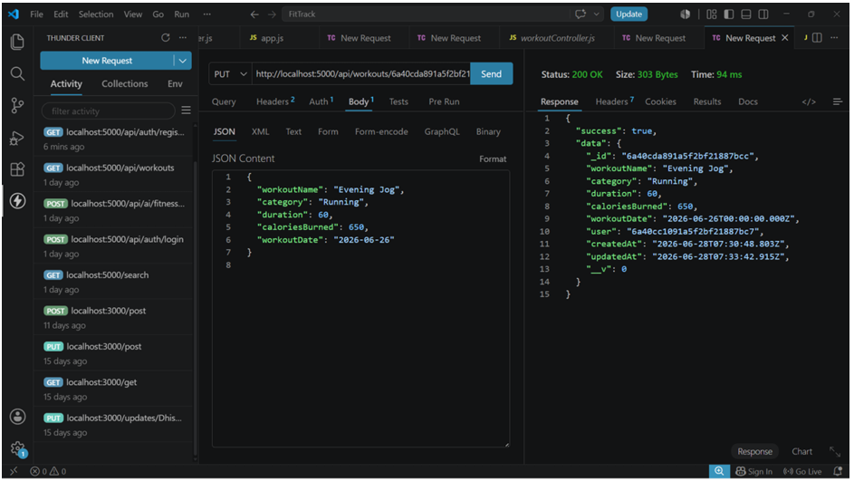

Delete Workout
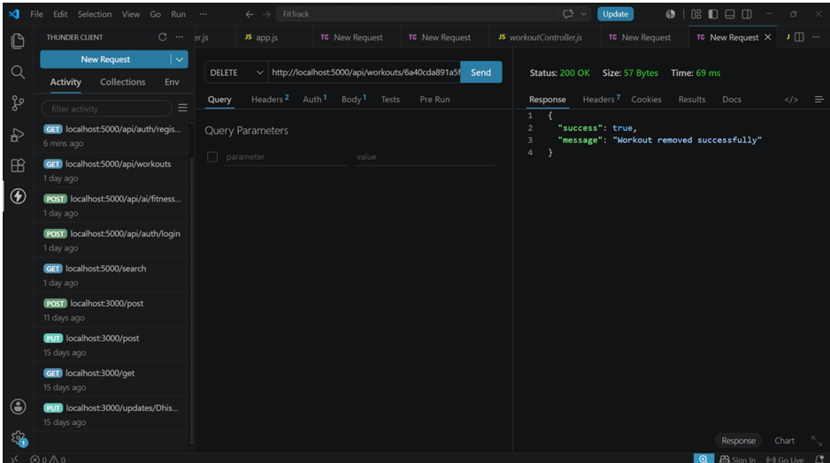

12. Known Issues
The following limitations may be present in the current version:
- Internet connectivity is required for Google Gemini API requests.
- AI responses depend on the availability and response of the Gemini API.
- The system requires correct environment variable configuration.
- MongoDB must be available for database operations.
- AI-generated recommendations should be treated as general fitness guidance rather than professional medical advice.
- The current system may not include wearable-device integration or advanced analytics.

13. Future Enhancements
The following features can be added in future versions:
- Nutrition Tracking
  - Food and calorie tracking.
  - Personalized nutrition suggestions.
- BMI Calculator
  - Calculate and monitor BMI.
- Wearable Integration
  - Connect fitness watches and other wearable devices.
- Workout Reminders
  - Notifications for scheduled workouts.
- Analytics Dashboard
  - Charts and graphs for fitness progress.
- Advanced AI
  - More personalized training plans based on workout history.
- Additional Fitness Services
  - Expand the application with more fitness-related features.

14. Conclusion
AI FitTrack provides a secure and scalable platform for fitness tracking and personalized workout assistance. The application combines RESTful APIs, MongoDB, JWT authentication, secure password hashing, and Google Gemini AI to provide users with workout management and intelligent fitness recommendations.
The modular architecture makes the system easier to maintain and extend. Future enhancements such as nutrition tracking, wearable integration, reminders, and advanced analytics can further expand the capabilities of AI FitTrack.

